Help – Passo-a-passo Config de Workflow Flex WS02000445
Materiais de Workflow Flexivel
-------------------------------------------------------------------------------
https://www.youtube.com/watch?v=DjWucp2X9T0
https://www.youtube.com/watch?v=MQa4gMWlIic

Seguir este BLOG para Buscar Agents
-------------------------------------------------------------------------------
https://community.sap.com/t5/technology-blog-posts-by-members/determining-sap-flexible-workflow-agents-with-custom-responsibility-rules/ba-p/13558459

Passo-a-passo
-------------------------------------------------------------------------------

0. Criar REQUEST Workbench
S4DK959723 TCGK1001964 SMART-EB-PORTAL - BL2012 - WF Flex – OTC CCM Liquid Provisõe

0. CRIAR badi implementation
BADI: RSM_BADI_STATIC_RULE
Implementação de ampliação Z_IM_RSM_BADI_STATIC_RULE
Implementação da BADI Z_IM_LIQ_PROVISOES
Classe de implementação ZCL_IM_LIQ_PROVISOES

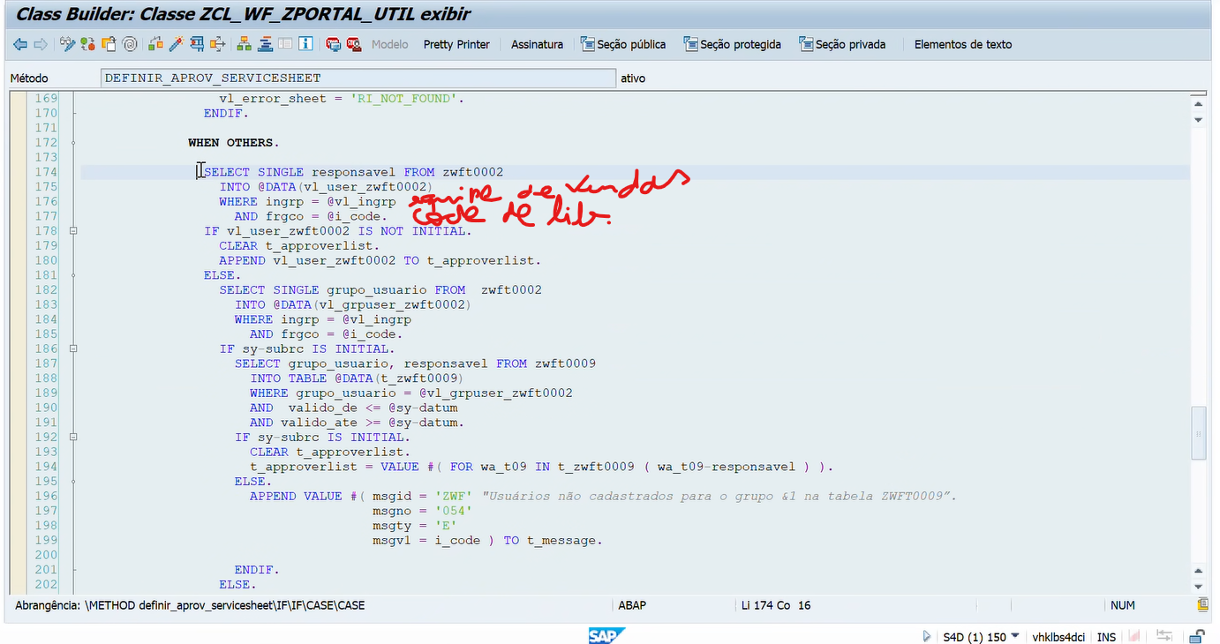

1. Administrar regras de responsabilidade
https://vhklbs4dci.sap.klabin.net:44300/sap/bc/ui2/flp?sap-client=100&sap-language=PT#ResponsibilityRule-manage&/?sap-iapp-state--history=TASH3MDIQE8HPIBCPLFV9RR1FB3VHT4AL4MIM4M1W&sap-iapp-state=TASE4GC7WX4LWC5UGH21JXVFDYWESVHYSFVYBDSCM
WS0200000495
ZZ1_CCM_AGENT
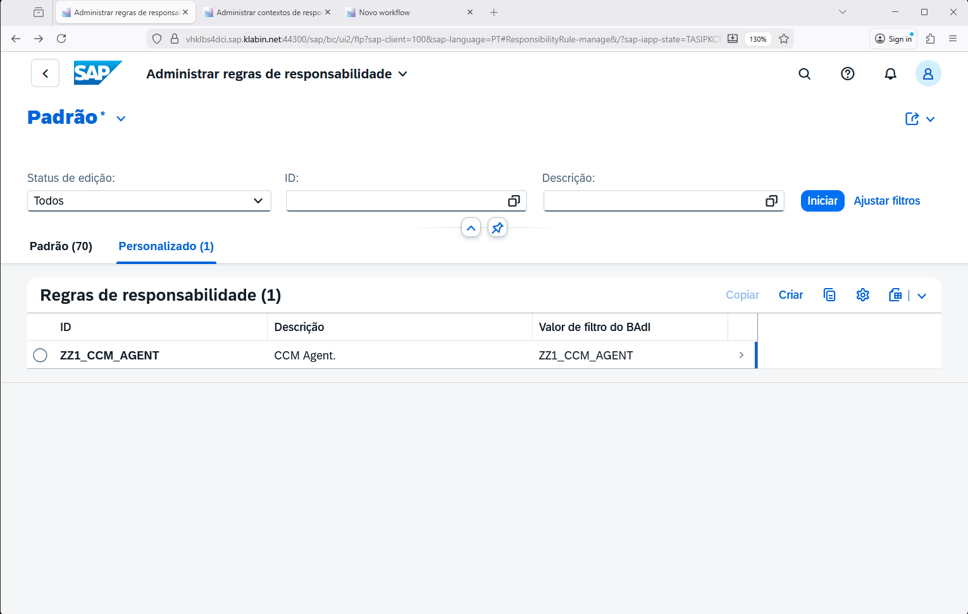
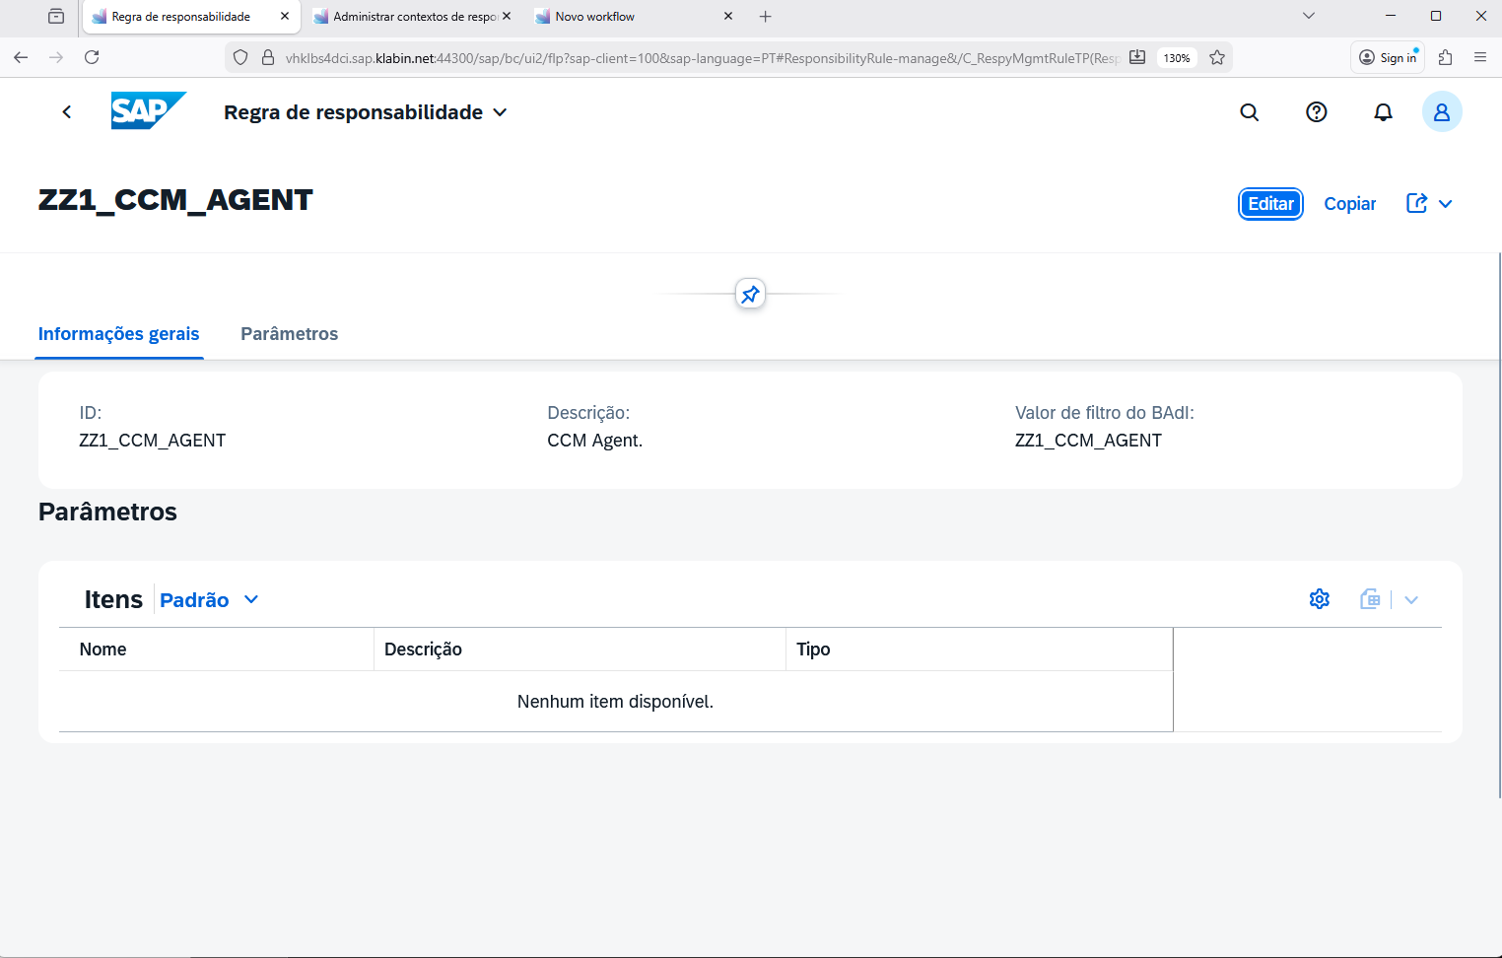

2. Administrar contextos de responsabilidade
https://vhklbs4dci.sap.klabin.net:44300/sap/bc/ui2/flp?sap-client=100&sap-language=PT#ResponsibilityContext-manage&/?sap-iapp-state--history=TASELFP2MHFDZR3VX2ML266QZ2YTCYBGCC9BCRRQ2&sap-iapp-state=TASIJJVUPAU3T3RB4R5F3UBXF7C8G8T49MB55WOSY

ZZ1_WS02000445
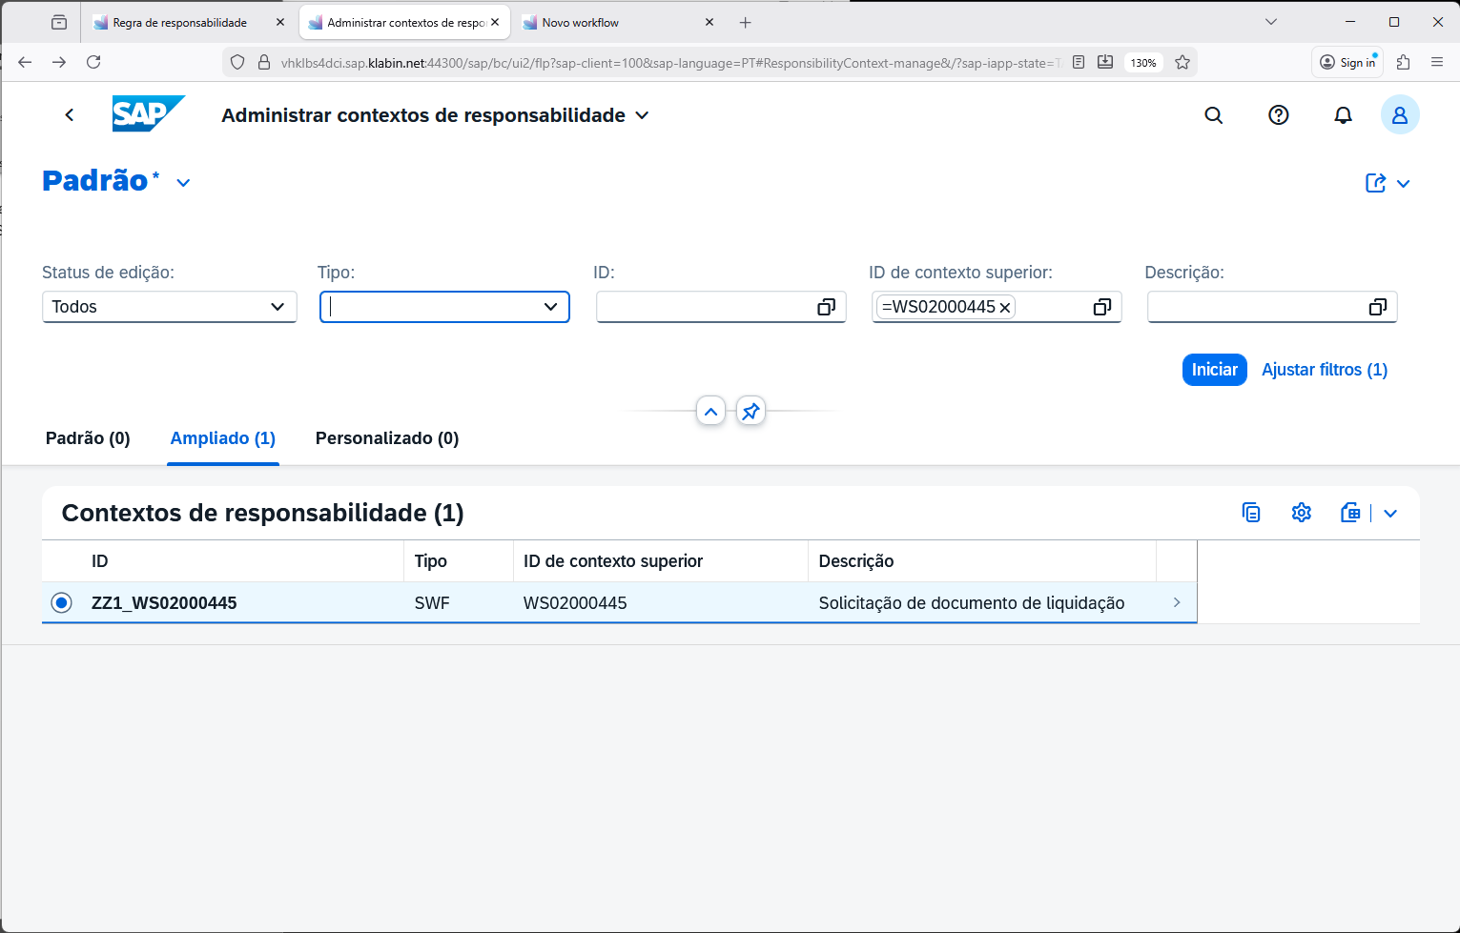

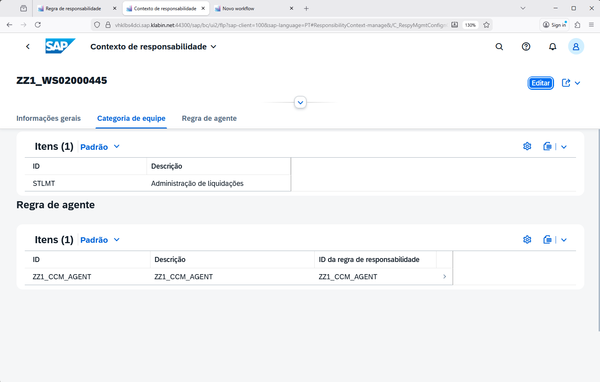

3. Configurar WF Etapa
https://vhklbs4dci.sap.klabin.net:44300/sap/bc/ui2/flp?sap-client=100&sap-language=PT#Workflow-showList
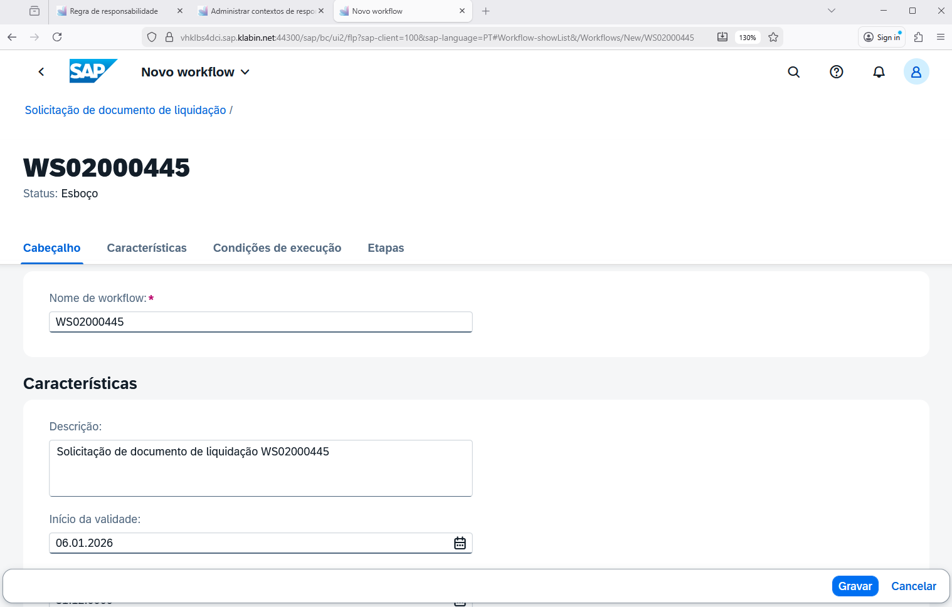
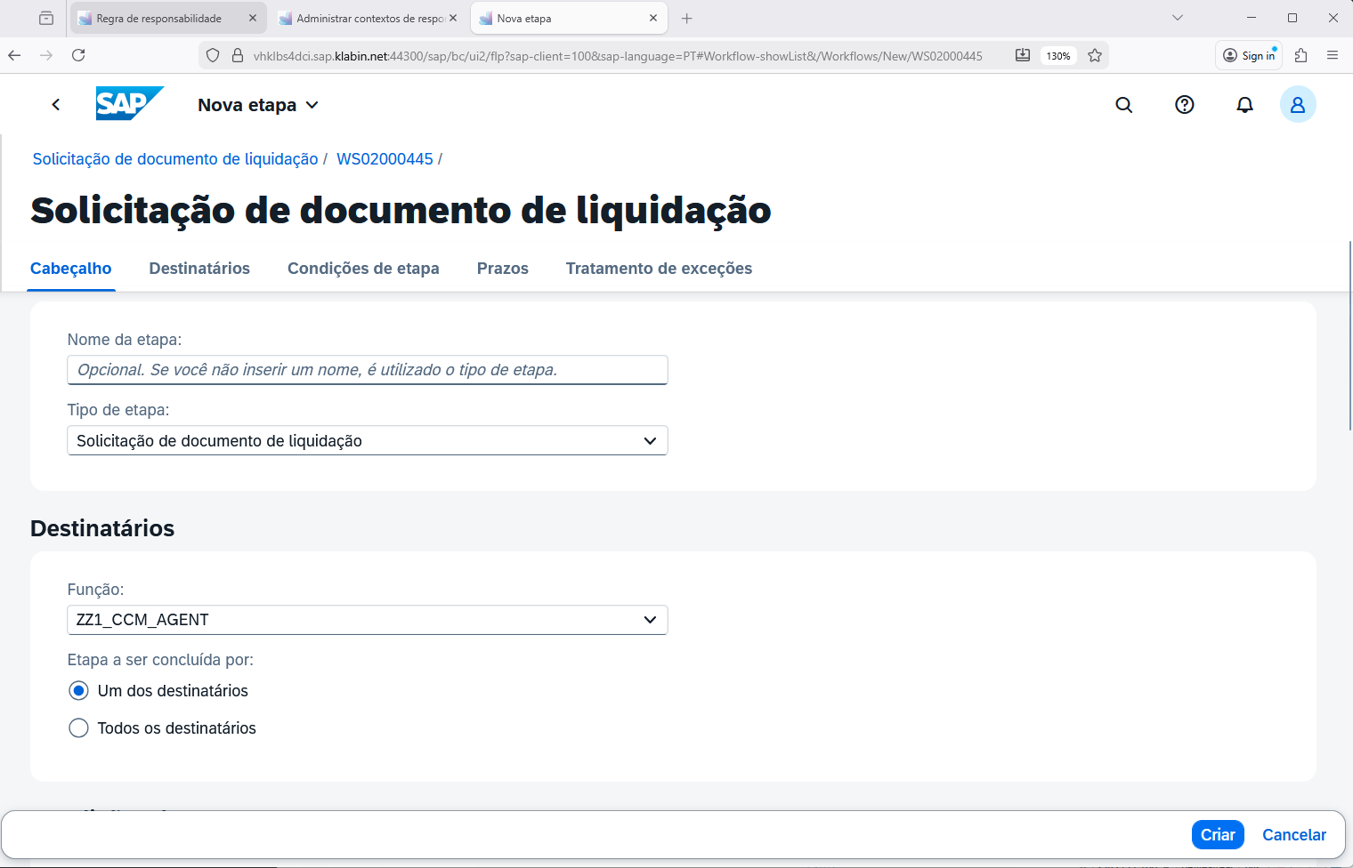

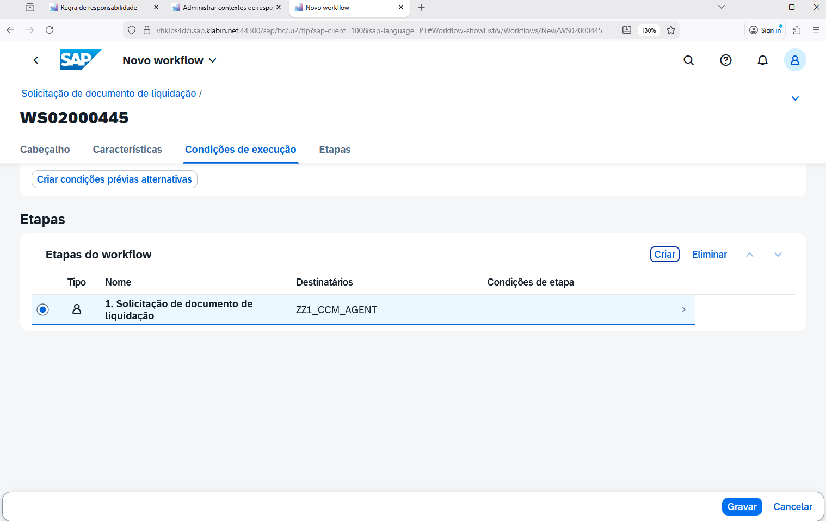

4. Configurar BADI para Condições
SWF_PROCESS_WORKFLOW_CONDITION
